1 Quantitate DNA (Optional)

Run Information
Date
Time
Operator

WG#-DNA Plate
Plate 1 ID
Plate 2 ID
Plate 3 ID

Standard DNA Plate
Plate ID

QNT Plate
Plate 1 ID
Plate 2 ID
Plate 3 ID

Comments

2 Amplify DNA (Pre-Amp)

Run Information
Date
Time
Operator

Batch Information
Batch Number
Number of Samples

Plates
WG#-DNA Plate ID
MSA3 Plate ID

Reagent Lot Numbers and Bar Codes
MA1
MA2
MSM
0.1N NaOH

☐Vortex plate at 1600 rpm for 1 minute.

☐Centrifuge plate to 280 × g at 22°C for 1 minute.

☐Incubate plate for 10 minutes at room temperature.

☐Vortex plate at 1600 rpm for 1 minute.

☐Centrifuge plate to 280 × g at 22°C for 1 minute.

Comments

WG#-DNA Sample IDs
Columns 1 - 4 of the Microtiter Plate
 | 1 | 2 | 3 | 4
A
B
C
D
E
F
G
H
Columns 5 - 8 of the Microtiter Plate
 | 5 | 6 | 7 | 8
A
B
C
D
E
F
G
H
Columns 9 - 12 of the Microtiter Plate
 | 9 | 10 | 11 | 12
A
B
C
D
E
F
G
H

3 Incubate DNA (Post-Amp)

Incubate in Hyb Oven for 20-24 Hours at 37°C.
Start Time
Stop Time

4 Fragment DNA (Post-Amp)

Run Information
Date
Time
Operator

Reagent Lot Numbers and Bar Codes
FMS

☐Centrifuge tubes to 280 × g.

☐Centrifuge plate to 50 × g for 1 minute.

☐Vortex plate at 1600 rpm for 1 minute.

☐Centrifuge plate to 50 × g for 1 minute.

Heat Block at 37°C for One Hour
Start Time
Stop Time

Comments

5 Precipitate DNA (Post-Amp)

Run Information
Date
Time
Operator

Reagent Lot Numbers and Bar Codes
PM1
100% 2 Propanol
100% 2 Propanol Date Opened

☐Centrifuge plate to 280 × g for 1 minute.

☐Vortex plate at 1600 rpm for 1 minute.

Incubate at 37°C for 5 minutes.
Start Time
Stop Time

☐Centrifuge plate to 280 × g for 1 minute.

Incubate at 4°C for 30 minutes.
Start Time
Stop Time

☐Centrifuge plate to 3000 × g at 4°C for 20 minute.

Air Dry at Room Temperature for 1 Hour
Start Time
Stop Time

Comments

6 Resuspend DNA (Post-Amp)

Run Information
Date
Time
Operator

Reagent Lot Numbers and Bar Codes
RA1

☐Vortex plate at 1800 rpm for 1 minute.

☐Centrifuge plate to 280 × g.

Comments

7 Hybridize DNA (Post-Amp)

Run Information
Date
Time
Operator

Reagent Lot Numbers and Bar Codes
PB2

Heat Block at 95°C for 20 minutes
Start Time
Stop Time

☐MSA3 plate cool down for 30 minutes

☐Centrifuge MSA3 plate to 280 × g

BeadChip Information
BeadChip 1 Serial Number
BeadChip 2 Serial Number
BeadChip 3 Serial Number
BeadChip 4 Serial Number

Hyb Oven Incubation at 48°C for 16 to 24 hours
Start Time
Stop Time

Comments

Track BeadChips 1-4 for the 24x1 HTS BeadChip Using Single-Channel Pipette Only  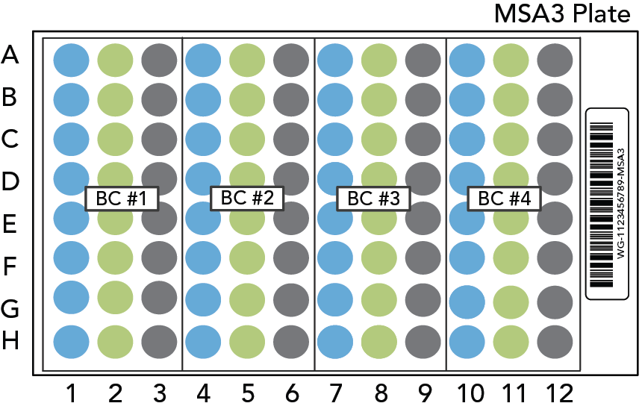 | 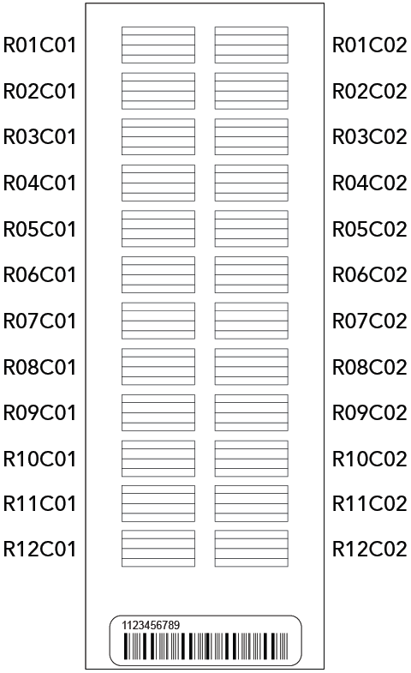 | Sample Section Naming Diagram
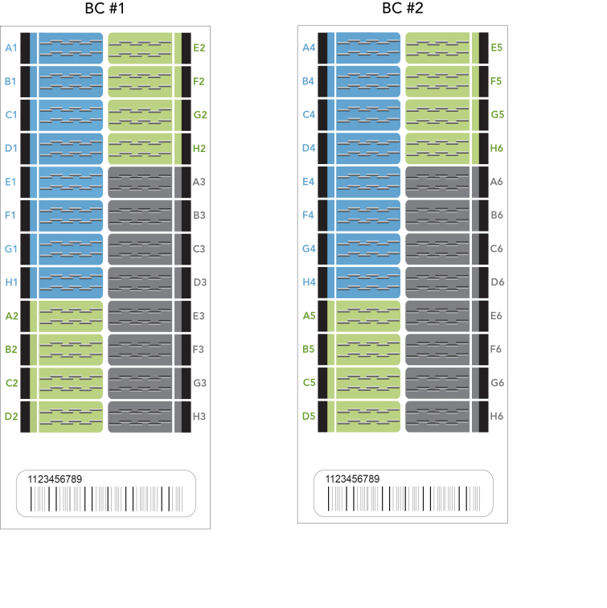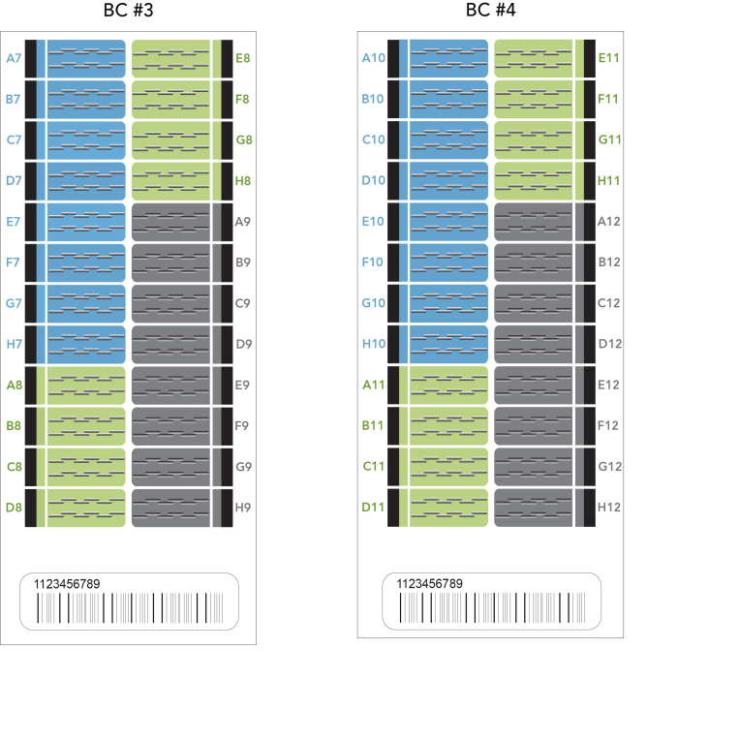

Track BeadChips 1-4 for the 24x1 HTS BeadChip  Adjustable Spacer Multi-Channel Pipette  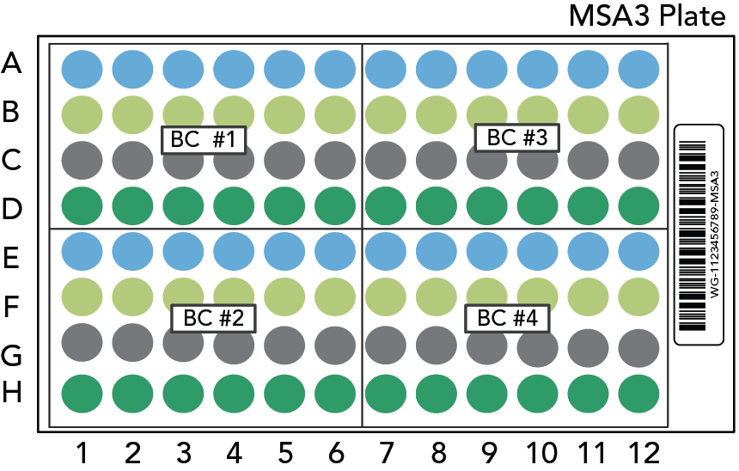 |  | Sample Section Naming Diagram
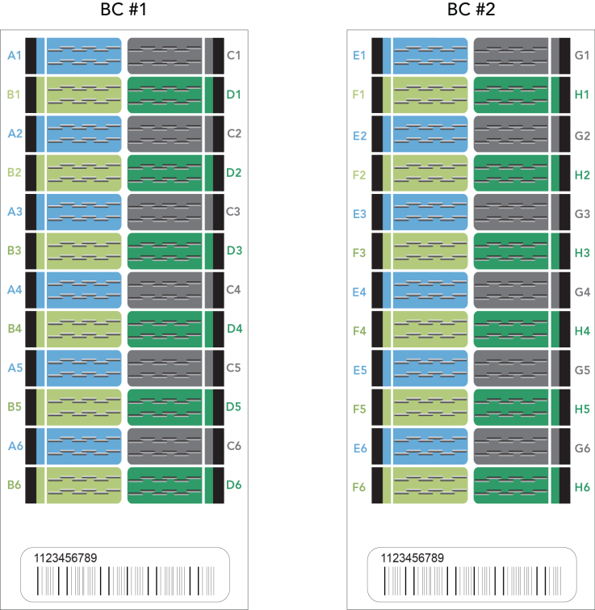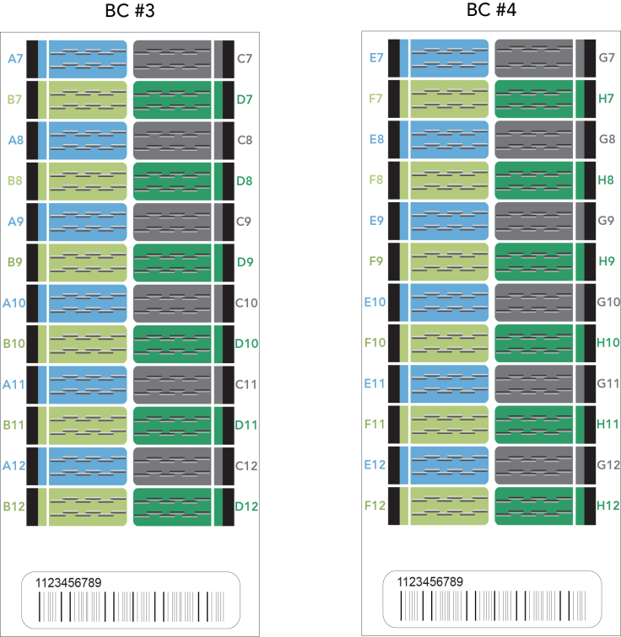

8 Wash BeadChip (Post-Amp)

Run Information
Date
Time
Operator

Reagent Lot Numbers and Bar Codes
PB1

Comments

9 Extend and Stain (XStain) BeadChip (Post-Amp)

Run Information
Date
Time
Operator

Reagent Lot Numbers and Bar Codes
RA1
LX1
LX2
EML
XC3
SML
SML Temperature
ATM
PB1
XC4
95% formamide/1mM EDTA
Alconox Powder Detergent
EtOH
EtOH Date Opened

Dry in Desiccator > 675 mm Hg (0.9 bar) for 50-55 minutes
Start Time
Stop Time

Comments

10 Image BeadChip (Post-Amp)

Run Information
Operator

BeadChip 1
Barcode Number
Scanner ID
Image Date

BeadChip 2
Barcode Number
Scanner ID
Image Date

BeadChip 3
Barcode Number
Scanner ID
Image Date

BeadChip 4
Barcode Number
Scanner ID
Image Date

Comments

